1. **Checking Capital Letters**

%{

#include<stdio.h>

%}

%%

[A-Z]+ { printf("%s\n", yytext); }

. ; // Ignore all other characters

%%

int yywrap() { return 1; }

int main() {

printf("Enter the input string:\n");

yylex();

return 0;

}

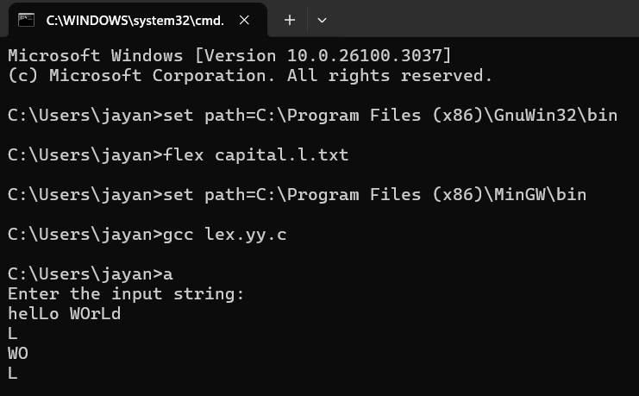

1. **Digit or Not**

%{

#include<stdio.h>

%}

%%

[0-9] { printf("Digit: %s\n", yytext); }

. { printf("Not a digit: %s\n", yytext); }

%%

int yywrap() { return 1; }

int main() {

printf("Enter a string:\n");

yylex();

return 0;

}

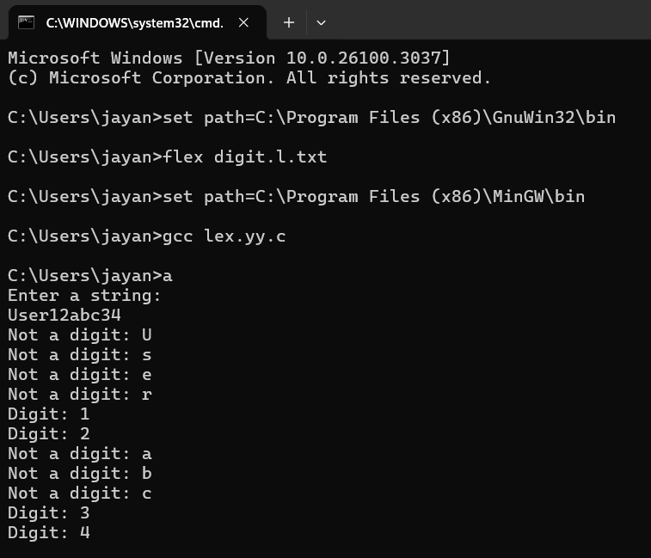

1. **Valid Mobile Number**

%{

%}

%%

[6-9][0-9]{9} {printf("\n mobile number valid\n");}

.+ {printf("\n mobile number invalid\n");}

%%

int yywrap(void){}

int main()

{

printf("\n enter the mobile number:");

yylex();

printf("\n");

return 0;

}

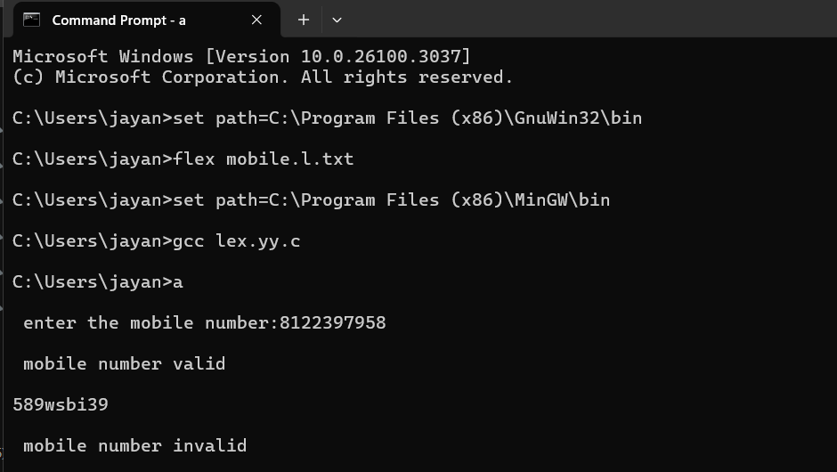

1. **Number of Vowels and Consonants**

%{

int vow_count=0;

int const_count=0;

%}

%%

[aeiouAEIOU] {vow_count++;}

[a-zA-Z] {const_count++;}

%%

int yywrap(){}

int main()

{

printf("enter the string of vowels and consonents:");

yylex();

printf("number of vowels are:%d\n",vow_count);

printf("number of consonents are:%d\n",const_count);

return 0;

}

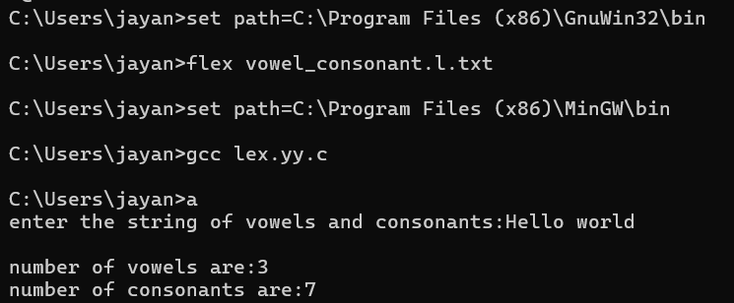

1. **Separate keywords and identifiers**

%{

#include <stdio.h>

%}

%%

if|else|while|int|switch|for|char { printf("\n%s is a KEYWORD", yytext); }

[a-zA-Z_][a-zA-Z0-9_]* { printf("\n%s is an IDENTIFIER", yytext); }

[ \t\n]+ { /* Ignore spaces, tabs, and new lines */ }

. { /* Ignore other characters */ }

%%

int yywrap() { return 1; }

int main() {

printf("Enter the input:\n");

yylex();

return 0;

}

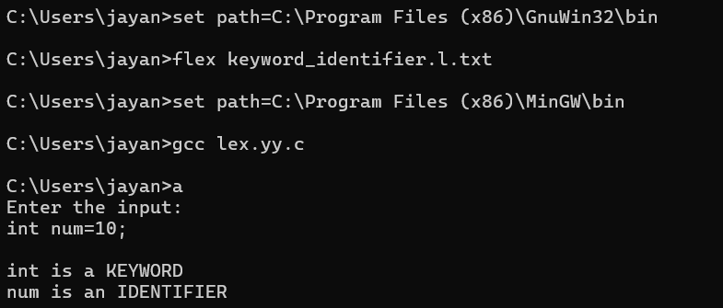

**6.Count positive and negative numbers**

%{

#include <stdio.h>

int positive_count = 0, negative_count = 0;

%}

%%

[-]?[0-9]+ {

int num = atoi(yytext);

if (num < 0) {

printf("Negative number: %d\n", num);

negative_count++;

} else {

printf("Positive number: %d\n", num);

positive_count++;

}

}

\n {/* Do nothing on new lines */}

. {/* Ignore other characters */}

%%

int main() {

printf("Enter numbers (Ctrl+D to stop input):\n");

yylex();

printf("\nTotal Positive Numbers: %d\n", positive_count);

printf("Total Negative Numbers: %d\n", negative_count);

return 0;

}

int yywrap() {

return 1;

}

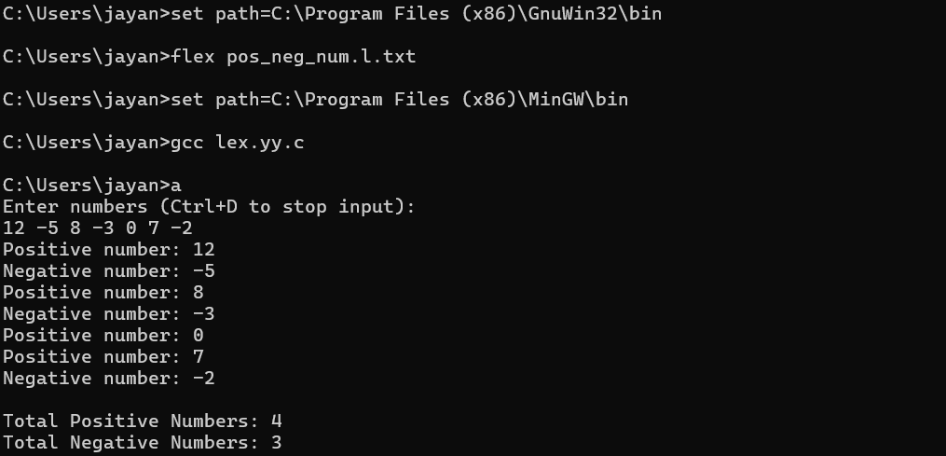

**7.Identify numbers and words**

%{

#include <stdio.h>

%}

%%

[0-9]+ { printf("Number: %s\n", yytext); }

[a-zA-Z']+ { printf("Word: %s\n", yytext); }

[ \t\n] { /* Ignore whitespace */ }

. { /* Ignore special characters */ }

%%

int yywrap() {

return 1;

}

int main() {

printf("Enter a statement:\n");

yylex();

return 0;

}

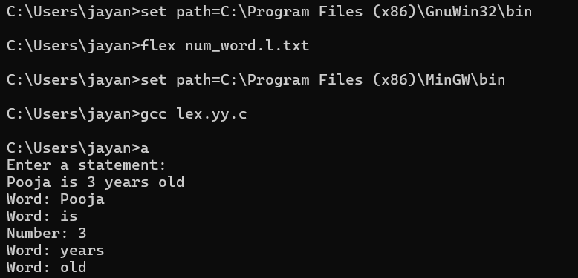

**8. Accept Vowel String**

%{

#include <stdio.h>

%}

%%

[aeiouAEIOU][a-zA-Z0-9]* { printf("String starting with vowel: %s\n", yytext); }

[ \t\n] { /* Ignore spaces, tabs, and newlines */ }

. { /* Ignore special characters */ }

%%

int yywrap() {

return 1;

}

int main() {

printf("Enter words:\n");

yylex();

return 0;

}

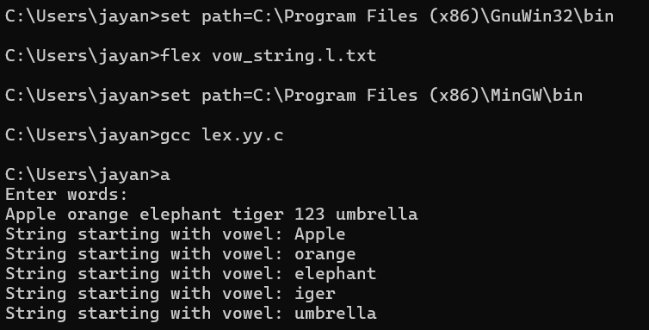

**9. Count number of characters, lines and words**

count_char_line_words.l.txt

%{

#include <stdio.h>

int char_count = 0, word_count = 0, line_count = 0;

%}

%%

\n { line_count++; char_count++; } // Count lines and characters

[a-zA-Z]+ { word_count++; char_count += yyleng; } // Count words

. { char_count++; } // Count all characters

%%

int yywrap() { return 1; }

int main() {

printf("Enter text (Ctrl+D to stop on Linux, Ctrl+Z on Windows):\n");

yylex();

printf("\nLines: %d, Words: %d, Characters: %d\n", line_count, word_count, char_count);

return 0;

}

count_char_line_words.c

#include <stdio.h>

int main() {

int a = 10, b = 20;

printf("Sum: %d", a + b);

return 0;

}

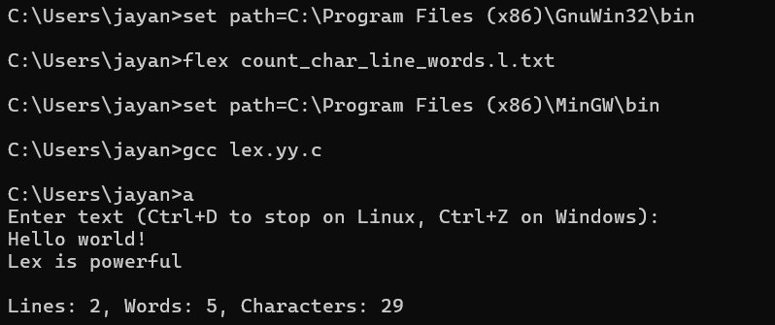

**10. Print all constants**